**TRƯỜNG ĐẠI HỌC DUY TÂN**

**TRUNG TÂMNGOẠI NGỮ**



**ĐỀ CƯƠNG ÔN TẬP**

**MÔN WRITING& SPEAKING**

**LƯU HÀNH NỘI BỘ**

**Đà Nẵng, 2017**

**MÔN WRITING**

Hình thức thi: bài tự luận trên giấy

Thời gian thi: 45 phút

Bài thi gồm có 2 phần:

Phần 1: Viết câu mô tả tranh dựa vào 3 từ hoặc cụm từ cho sẵn (80 điểm)

Phần 2: Viết một bài luận đưa ra ý kiến (120 điểm)

**MẪU ĐỀ THI**

|  |  |  |  |  |  |
| --- | --- | --- | --- | --- | --- |
| Trường ĐH Duy Tân | | **ĐỀ THI KHẢO SÁT TIẾNG ANH**  Môn: TOEIC **Writing**  Khối lớp:  Học kỳ: Năm học :  Thời gian làm bài: **45 phút**  **Mã số SV: ………………………………………**  **Họ và tên SV: ……………………………………..** | | | Đề số: |
| **Chữ ký giám thị** | **Điểm số** | | **Điểm chữ** | **Chữ ký giám khảo** | |
|  |  | |  |  | |

**(Thí sinh làm bài trên đề thi)**

**Part I. Write one sentence based on each of the pictures and the three words or phrases given. (80 marks)**

1. **smile / because / gift**

|  |  |
| --- | --- |
| https://encrypted-tbn0.gstatic.com/images?q=tbn:ANd9GcT467mUQD4sD85s9JkDOXf2n94r9wTPQjkEIuJWlf39rwSLLFi7ew | Answer: The man is smiling because he is receiving a gift box from his girl friend. |

1. **stand / although / rain**

|  |  |
| --- | --- |
| http://www.pazsnewyorkminute.com/wp-content/uploads/image/Blessing%20of%20the%20Animals%202(1).jpg | Answer: They are standing in front of the church although it is raining. |

1. **read / and / colleague**

|  |  |
| --- | --- |
| http://collegepals.org/wp-content/uploads/2011/12/student-listening-and-communication-in-classroom.jpg | Answer: The man is reading the book, and his colleagues are listening to him. |

1. **woman / while / read**

|  |  |
| --- | --- |
| http://st.depositphotos.com/2087445/2349/v/380/depositphotos_23499123-Young-woman-reading-a-book-on-a-public-bench.jpg | Answer:  The woman is reading a book while waiting for her friend. |

1. **boy / whereas / sit**

|  |  |
| --- | --- |
| http://thumb9.shutterstock.com/display_pic_with_logo/64260/224222392/stock-photo-education-high-school-technology-and-people-concept-smiling-student-boy-with-tablet-pc-laptop-224222392.jpg | Answer: The boy is standing whereas his friends are sitting. |

**Part II. Essay Writing (120 marks)**

Choose **ONE** topic and write a complete opinion essay.

Topic 1: Do you agree or disagree with the following statement? A small town is a better place than a big city to raise children. Support your answer with specific reasons and examples.

Topic 2: Some people use public transportation (buses and subways) to get around a city. Others use private cars. Which do you prefer? Support your answer with specific reasons and examples.

***Follow these guidelines:***

**Introduction (30 marks)**

Write ONE introductory paragraph, which includes:

* (a) general statement(s), (1 - 2 sentences)
* a thesis statement (1 sentence)

**Body Paragraphs (60 marks)**

Write TWO paragraphs for the essay body. Each paragraph consists of:

* a topic sentence,
* one or two sentences givinga reason or an example for the main point that supports your opinion.

**Conclusion: (30 marks)**

Write ONE concluding paragraph, which gives:

* a summary of the main points, or
* a restatement of your thesis in different words. (1-2 sentences)

You can add your final comment on the subject, based on the information you have provided. (1 sentence)

------------------------------------------------------------------------------------------------------------------------------------------------------------------------------------------------------------------------------------------------------------------------------------------------------------------------------------------------------------------------------------------------------------------------------------------------------------------------------------------------------------------------------------------------------------------------------------------------------------------------------------------------------------------------------------------------------------------------------------------------------

------------------------------------------------------------------------------------------------------------------------------------------------------------------------------------------------------------------------------------------------------------------------------------------------------------------------------------------------------------------------------------------------------------------------------------------------------------------------------------------------------------------------------------------------------------------------------------------------------------------------------------------------------------------------------------------------------------------------------------------------------

**Part I. Write one sentence based on each of the pictures and the three words or phrases given.**

1. **man/ happy/ because**

|  |  |
| --- | --- |
| Description: Image result for man smile | Answer: The man looks happy because his salary is raised. |

1. **students / and / teacher**

|  |  |
| --- | --- |
| Description: C:\Users\DELL\Documents\Teach a class.jpg | Answer: The student are learning, and the teacher is explaining the lesson to one of them. |

1. **woman / while / sit**

|  |  |
| --- | --- |
| Description: C:\Users\DELL\Documents\woman-reading-book-in-the-park-2.jpg | Answer: The woman is reading a book while she sitting on the bench. |

1. **man / whereas / discuss**

|  |  |
| --- | --- |
| Description: C:\Users\DELL\Documents\teamdiscussion.jpg | Answer: The man is standing whereas his colleagues are sitting. |

1. **stand/ wall/ conversation**

|  |  |
| --- | --- |
| Description: Image result for a man and a woman are standing by the wall and talking | Answer:  The man and the woman who are having a conversation are leaning against the wall. |

1. **woman/ hold/ table**

|  |  |
| --- | --- |
| Description: Image result for a woman is working at a table | Answer:  The woman holding a cup is sitting at the table. |

1. **grandfather/ lucky money/ give**

|  |  |
| --- | --- |
| Description: Image result for bà cho các cháu tiền lì xì | Answer:  The grandfather is giving lucky money to his grandchildren. |

1. **buy/ car/ look**

|  |  |
| --- | --- |
| Description: Image result for The man who is buying a car is pointing at his favorite one. | Answer:  The woman who is buying a care looks very happy. |

**9. focus/ study/ obvious**

|  |  |
| --- | --- |
| Description: Image result for the man focus on studying | Answer:  It’s obvious that the boy is focusing on his study. |

**10. There/ who / against**

|  |  |
| --- | --- |
| Description: 2509162-portrait-of-a-boy-standing-near-the-tree-in-the-park | Answer:  There is a boy who is standing against a tree. |

**11. eat / while / drive**

|  |  |
| --- | --- |
| Description: eating-while-driving | Answer:  She is eating a hamburger while she is driving. |

**12. if / fit / buy**

|  |  |
| --- | --- |
| Description: dressing_room | Answer:  If the dress fits her, she will buy it. |

**13. woman / walk / stair**

|  |  |
| --- | --- |
| Description: 17_take-the-stairs | Answer:  The woman is walking up the stairs. |

14. **They / because / cold**

|  |  |
| --- | --- |
| Description: xCXAthtv | Answer:  They are wearing warm clothes because it is very cold. |

**15. outdoors / and / talk**

|  |  |
| --- | --- |
| Description: Kết quả hình ảnh cho pictures in toeic speaking | Answer:  They are sitting outdoors and talking together. |

**16. work / that / on time**

|  |  |
| --- | --- |
| Description: Kết quả hình ảnh cho pictures in toeic speaking | Answer:  The woman that is holding a pencil always works on time. |

**17. carry / while /airport**

|  |  |
| --- | --- |
| Description: Kết quả hình ảnh cho pictures in toeic speaking | Answer:  The men are carrying luggage while they are in the airport. |

**18. show / how / cook**

|  |  |
| --- | --- |
| Description: Kết quả hình ảnh cho pictures in toeic speaking | Answer:  The woman is showing the girl how to cook. |

**19. beautiful / moreover / dance**

|  |  |
| --- | --- |
| Description: Kết quả hình ảnh cho pictures in toeic speaking | Answer:  The woman is very beautiful; moreover, she dances very well. |

**20. storm / therefore / damage**

|  |  |
| --- | --- |
| Description: http://media.cleveland.com/plain_dealer_metro/photo/severe-storm-ohiojpg-2fd8cf352a74735d.jpg | Answer:  There was a storm last night; therefore; the car is damaged |

**Part II. Essay Writing**

**Topic 1:** In some countries, people are no longer allowed to smoke in many public places and office buildings. Do you think this is a good rule or a bad rule? Use specific reasons and details to support your option.

**Topic 2:**  Some people prefer to eat at food stands or restaurants. Other people prefer to prepare and eat food at home. Which do you prefer? Use specific reasons and examples to support your answer.

**Topic 3:** It is better for children to grow up in the countryside than in a big city. Do you agree or disagree? Use specific reasons and examples to develop your essay.

**Topic 4:** Employers should pay young people the same salary as older colleagues doing the same job. To what extent do you agree or disagree? Use specific reasons and examples to develop your essay.

**Topic 5:** Do you agree or disagree with the following statement? Businesses should do anything they can to make a profit. Use specific reasons and examples to support your opsition.

**Topic 6:** People listen to music for different reasons and at different times. Why is music important to many people. Support your answer with specific reasons and examples.

**Topic 7:** Do you agree or disagree with the following statement? Watching TV is bad for children. Use specific reasons and examples to develop your essay.

**Topic 8:** Some people prefer to spend their free time outdoors. Other people prefer to spend their leisure time indoors. Would you prefer to be outside or would you prefer to be inside for your leisure activities? Use specific reasons and examples to explain your choice.

**MÔN SPEAKING**

Bài thi gồm 8 phiếu (tickets). Sinh viên thi theo hình thức bắt thăm chọn một phiếu bất kì để trả lời. Sinh viên có một cơ hội đổi phiếu. Cấu trúc mỗi phiếu (đề) gồm các phần như sau:

* Phần 1: Mô tả tranh (60 điểm). Sinh viên có 30 giây chuẩn bị và 45 giây trình bày.
* Phần 2: Thể hiện quan điểm cá nhân (140 điểm). Sinh viên có 15 giây chuẩn bị và 60 giây trình bày.

**2. Mẫu đề thi:**

**PART I: Describing a picture (**3 marks**)**

*Directions*: In this part of the test, you will describe a picture in as much detail as you can. You will then have 30 seconds to prepare your response. Then you will have 45 seconds to speak about the picture.



**PART II**: **Express an Opinion** (7 marks)

*Directions*: In this part of the test, you will give your opinion about a specific topic. Be sure to say as much as you can in the time allowed. You will have 15 seconds to prepare. Then you will have 60 seconds to speak.

***Question:***

*Some people prefer to take a job that does not pay well but does provide a lot of time off from work. What is your opinion about taking a job with a low salary that has a lot of vacation time? Give reasons for your opinion.*

**Dưới đây là một số tình huống và ngữ cảnh thường gặp trong các câu hỏi của bài thi TOEIC phần Nói**:

**PART I: Describing a picture**

**1.** What I can see is the picture of a supermarket. In the picture, there is a woman. She is wearing a T-shirt and she has long hair. She is holding something in her right hand. I think she is very beautiful.

**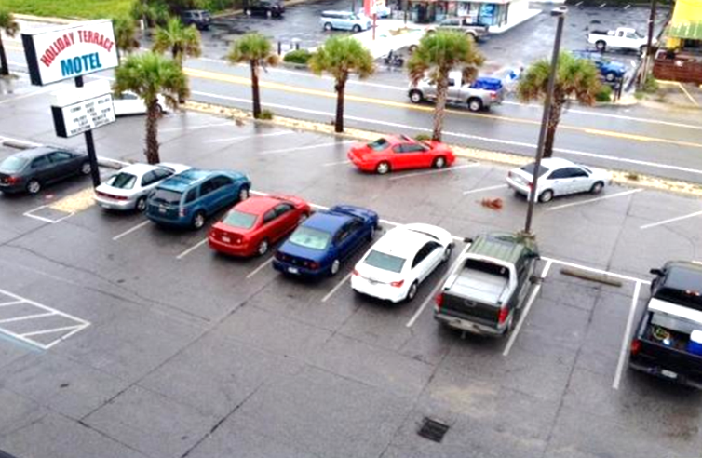2.** The picture shows a car park. There are many cars parked in a line and some trees on the street. This is a nice car park.

**3.** The picture might be taken on a street. In the picture, I can see two people. A woman is wearing glasses and a man is hugging her. They are smiling. The woman is pointing at something. Each of them is standing next to a bicycle. I think they are very happy.

**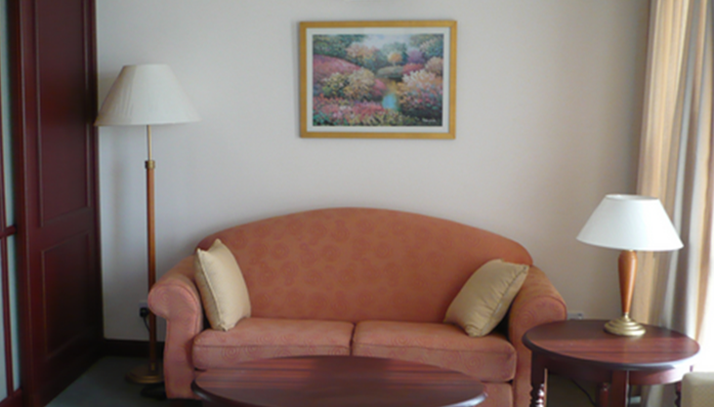4.** This is a picture of the living room. In the picture, I can see round table on the right. There is a picture on the wall. The sofa is between the two lamps. I think it is very quiet because no one is in the room.

**5,** The picture might be taken at their house. In the picture, I can see four people. They look like a family and they are eating breakfast. There is a lot of food on the table. The boy and the girl are wearing a white T- shirt. They are smiling so I think they are happy.

**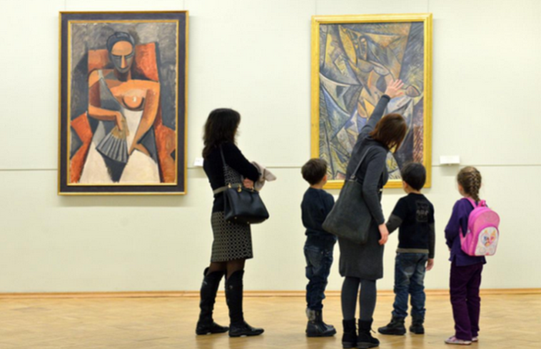6.** What I can see in the picture is a gallery. I can see five people in the picture. The woman is standing beside the children. There are two paintings on the wall. They are looking at the paintings very attentively, maybe they are very happy.

**7.** What I can see is the picture of the market. There are many people. They are selling and buying food. The man is wearing a T-shirt and an apron. Maybe, he is a salesman. The woman on the right is wearing the shirt and has short hair. She is giving the money to him. The woman on the left is tasting something. I can see they are very serious.

**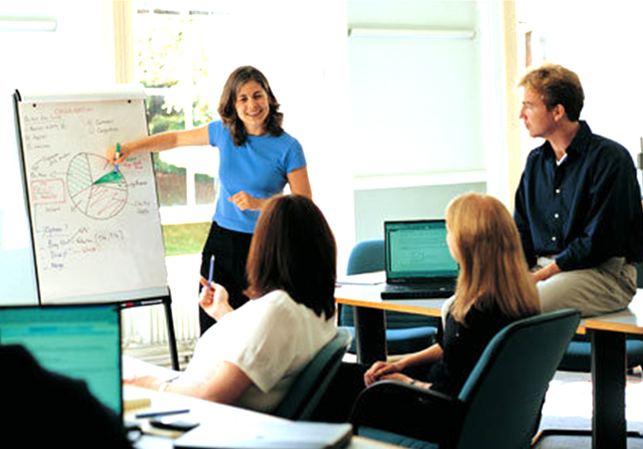8.** What I can see is the picture of the meeting. In the picture, I can see four people. There are three women and a man. They look very focused. The man is sitting on the table. The woman is presenting information to the three people in the room. I think they are colleagues in the company. They are very happy.

**9.** There are two people in the picture. They are sitting in a coffee shop. There are two glasses on the table. The man is looking at the cellphone. The woman is holding the glass and looking outside. The man is wearing a shirt. They are not talking to each other. I think maybe they are having a problem.

**10.** In the picture, I can see four people, two men and two women. They are standing in the building. They are standing and talking to one another. Maybe, they are discussing work and they are colleagues in the same company. They are smiling, so I think they are very happy.

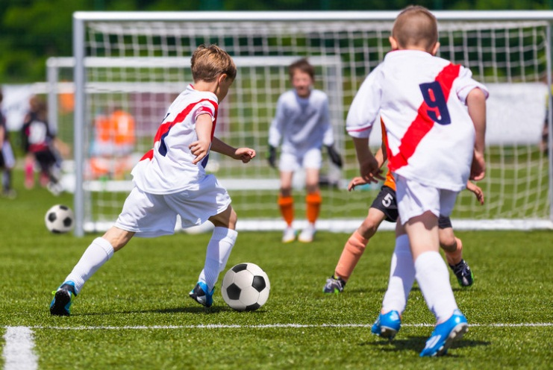

11. This is a picture of a football match. In the picture, there are four boys. They are playing soccer. They are wearing soccer uniform. I think the children are very happy when playing together.

**12.** What I can see is the picture of a family. In the picture, there are six people. They are sitting on the lawn. There are very many trees behind them. Maybe they are having a picnic in the park. All family members look so happy.

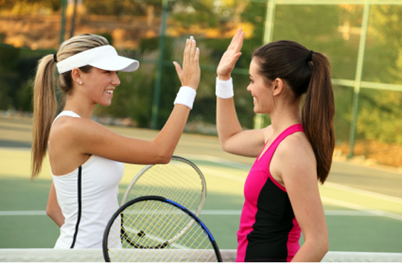**13.** This picture may be taken at a tennis court. The woman on the left is wearing a white hat and sport wears. The woman on the right has black hair. They are going to do a high five. I think they are tired but they feel happy.

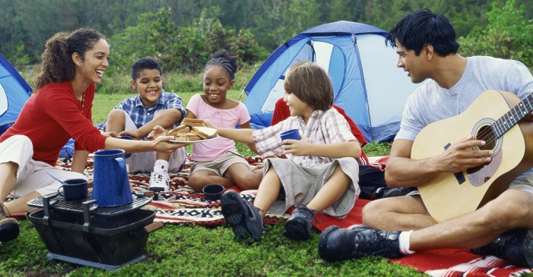**14.** What I can see is the picture of a family. In the background, there is a tent and many trees. Maybe, they are going on a picnic in the park. The man is holding the guitar and the woman is holding a dish of food. They are laughing very happily.

15. In the picture, I can see five people. On the table, there is a lot of food and water. Maybe, they are eating in the restaurant. In the middle is a woman, she has a long hair. There are many friends sitting around her. They look very happy because they are smiling nicely.

16. As you can see, there are a woman and a boy on the picture. They are cooking the food. Maybe, she is the boy’s mother. The boy is standing next to her. He looks very lovely. He is watching his mother while she cooking food. I think they are so happy.

17. What I can see is the picture of a trip. There are five people in the picture. There are two men and three women. The three women are standing between the two men. In the foreground, the man who is wearing a hat, is carrying a suitcase. In the back ground, there is a picture of a plane, clouds and globe. I think they are very happy.

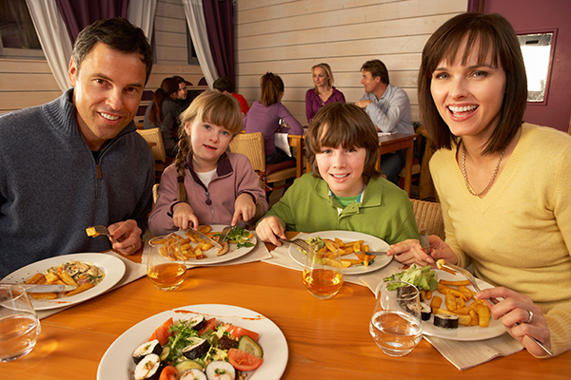18. As you can see they are many people in the picture. Maybe, they are in the restaurant. The family members are eating dinner together. There are many kinds of food on the table. I think the meal is very delicious.

19. In the picture, maybe taken in a shopping centre. In the picture, I can see a couple walking arm in arm. The man is wearing a shirt, black jeans and black shoes. He is holding three bags on his two hands. The woman holding three bags on her left hand. She is has long black hair. I think they are very happy.

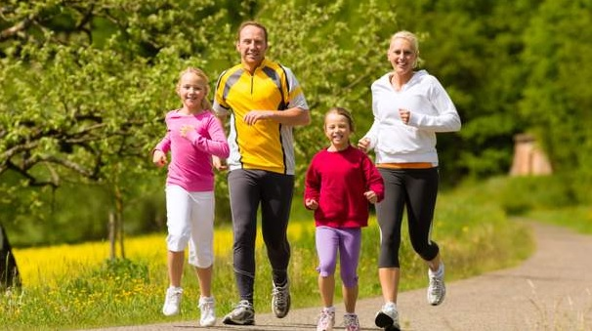20. The picture may be taken in a park. In the picture, I can see four people. They are wearing T-shirts and jogging together in the park. I can see they are smiling, so I think this is a happy family.

**PART II**: **Express an Opinion** (7 marks)

*Directions*: In this part of the test, you will give your opinion about a specific topic. Be sure to say as much as you can in the time allowed. You will have 15 seconds to prepare. Then you will have 60 seconds to speak.

*1. Some people enjoy jobs in which they do the same work every day. Others enjoy jobs that involve challenging from project to project. Which type of job would you prefer and why?*

**Answer:**

Some people enjoy jobs in which they do the same work every day. Others enjoy jobs that involve challenging from project to project. In my opinion, I would prefer a job that involves challenging from project to project.

First of all, I don’t really like doing the same thing every day because it will make me lazy to think.

Secondly, I like to meet new people. We can exchange experiences and learn more knowledge.

Finally, I think doing the same things all the time could be really boring. And this will reduce the quality of work

In conclusion, a challenging job from the project to project will help me meet more co-workers and gain more experience.

*2. Do you agree or disagree with the following statement? “It’s more important to eat a good diet than to exercise a lot.” Support your choice with reasons and details.*

**Answer:**

=> As we all know, health is one of the most important factors of human life. There are many ways to maintain a good health, and one of those is to have a good diet. There is a statement that “It’s more important to eat a good diet than to exercise a lot”, but in my opinion, I disagree with it because of the following reasons

- First of all, exercise is a very important part of a healthy lifestyle. It's good for your health, for your heart and for helping you have a beautiful body.

- Next, exercise it is fun. You can play sports with your family members for more fun time together.

- Finally, eating a good diet can be healthy, but if you don’t move your body, it will become weak. So you should use that energy to move.

- In conclusion, I have to say that exercise and diet are equally important.

*3. Some companies prefer to promote their current employees to management positions, but other companies prefer to recruit new managers from outside the company. Which do you prefer and why?*

**Answer:**

=> A good CEO always wants to bring their companies into the top class. To achieve that goal, recruiting good manager to oversee the work of employees is an important thing that we can’t deny. Some companies prefer to promote their current employees to management positions, but other companies prefer to recruit new managers from outside the company.In my opinion, I prefer to promote a company’s current employees to management positions.

- First of all, Employees are willing to work hard for the company when there is a chance for them to be promoted to a management position. This encourages young people work harder and dedicate more for company

- Secondly, Each team wants to have a manager who knows the members very well, so they help company reduce risk and save time at work.

- In short, Promoting the company's current employees to management positions is a good thing for employers. They will help the company get the job done the fastest

*4. Do you agree or disagree with the following statement? “Advertising has a big influence on consumer buying decisions.” Give specific reasons and examples to support your opinion.*

**Answer:**

=> In order to bring the products to the customers, advertising is one of essential step that we can’t ignore. Some people support the idea that “Advertising has a big influence on consumer buying decisions.”I agree with that idea because of the following reasons.

- First of all, Advertising gives good information about products and services to a lot of consumers. People can choose the right product for their needs based on advertising.  
- In addition, advertising makes shopping simpler and more time-efficient. For example, when buying a new product they can find the necessary information on the advertising.  
- In short, I believe that advertising has a big influence on consumer buying decisions. They can save a lot of time and money for their choice

*5. Some people think a good relationship between coworkers is good for business. What do you think about this?*

**Answer:**

=> The cooperation among workers is the most important factor that influence the results of a company. Some people think that a good relationship between coworkers is good for business, and in my opinion, I do agree with that thought.

- First, When people are close to their coworkers, they can enjoy their work and their time at the office more. They can help and support each other to get things done.

- Secondly, A harmonious working environment can help managers control employees. For example, if coworkers are nice to one another, the manager will not have to solve arguments among them.

- In conclusion, a business can not be successful if it lacks of good relationship among coworkers

*6. What are the benefits of working with your close friends? Support your answer with specific reasons and examples.*

**Answer:**

=> A close friend is the one who can understand us more than ourselves, he or she is also the one that helps us to overcome any difficulty. So what would it be if we can work together with our close friends. In my point of view, working with my close friends gives me a lot of benefits.

- First, I feel less stressed at work. I can ask for help from my best friend, and they will give many good ideas to get things done

- Secondly, If I work with my close friends, we can motivate each other.When I fail, my best friend will be with me when I need them the most

- In summary, having a close friend to work with will make you happier and motivated to get you things done.

*7. Do you agree or disagree with the following statement? “High school students should be able to choose which subjects they want to study.” Give specific details and reasons to support your opinion.*

**Answer:**

=>A good education is a very important aspect to build up the characters as well as the knowledge of a person. But what is a good education? Should we have different methods to teach different levels of study? Recently, there’s an idea that “High school students should be able to choose which subjects they want to study”, and in my perspective, I agree completely with this for several reasons.  
- First of all, each high school student has different dream what they want to be. To be specific, students don't need to learn subjects that are not related to the job that they want to do in the future.  
- Secondly, students don't enjoy learning about not interested. For example, when I was a high school student, I didn't want to study biology and I couldn't be concentrated to this class, so I got a lower score. It made me frustrated.   
- In sum, for these reasons, I think that it is vital for students to choose which subjects they want to study.

*8. Do you agree or disagree with the following statement: “Attending a company training session to get information is much better than getting information on the internet”. Support your answer with relevant ideas and examples.*

**Answer:**

=> Some people support that practicing gives us more experience than studying only theories. This is true in many aspects, and it’s especially useful for you and your work. An idea states that “attending a company training session to get information is much better than getting information on the internet”, but in my opinion, I disagree with this statement for some of below reasons.

- First, Getting information on the internet is much faster than attending a company training session.

- Secondly, I can manage my time with more freedom.

- In short, it isn’t better to get information from a company training session than to get information on the internet because of the above reasons.

*9. Do you agree or disagree with the following statement: “All students should be required to wear uniforms at school”. Support your answer with relevant ideas and examples.*

**Answer:**

=> While going to school, there are many things that a student must do based on the rules, and one of those things is wearing uniform. A lot of contrary ideas have been issued because of this rule, and in my perspective, I agree with that for several reasons.  
- First of all, wearing uniforms helps them focus more on studying. To be specific, they will spend less time worrying about what to wear.   
- Secondly, wearing uniforms saves money. For example, When I was young, my school didn't require student to wear uniform, so we needed to buy more clothes.   
- For these reasons, I think it is better for student to wear uniforms while going to school.

*10. Do you agree or disagree with the following statement: “Bonus is the most effective way to reward outstanding employees.*

**Answer:**

=> In a company, good employees are always be rewarded if they perform better than other employees. There are many ways to reward outstanding workers, but In my opinion, I believe that the bonuses are the most effective way to do so.  
- First of all, recently, the cost of living has become more expensive. To be specific, people need more money than before.   
- Secondly, offering bonuses makes employees motivated. For example, if employees get a bonus, they can be more confident.   
- In short, I think the bonuses are the greatest way to recognize employees who do well.

*11. Do you agree or disagree with the following statement? Businesses should do anything they can to make profit. Use specific reasons and examples to support your opinion.*

**Answer**

=> In the market, businesses always want to get the biggest profit for themselves. Some people think that businesses should do anything they can to make profit, but In my opinion, I disagree with that because of some of following reasons.

First of all, if businesses can do anything, that means they can violate the law to seek profit

Secondly, businesses can deceive consumers to buy poor-quality products and services

Finally, businesses can hardly develop in a sustainable manner

In conclusion, the businesses you shouldn’t do anything they can to make profit.

*12. Do you agree or disagree with the following statement? The most important aspect of a job is the money a person earns. Use specific reasons and examples to support your opinion.*

**Answer**

=> We all know that the very main purpose of working is to earn money. Therefore, lots of people believe that the most important aspect of a job is the money a person earns. In my opinion, I don’t think it’s true.

* First of all, Besides salary a person can earn doing a job, He can expand his social relationships
* Secondly, He can improve several professional and soft skills
* Finally, He can get a promotion if performing excellently in his job.
* In conclusion, a job can offer us more things than just money. If you love your job, you can find many useful things besides your money

*13. People work because they need money to live? What are some other reasons that they work? Discuss one or more of these reasons. Use specific reasons and examples to support your opinion.*

**Answer**

=> Money is an very important thing. We all need money to survive in this society, thus, many people think that money is the main reason why they go to work. In my opinion, besides that reason, people go to work for some other reasons:

- First of all, They go to work to satisfy their personal ambitions and demand

- Secondly, They do a job since they want to contribute to the development of a community or a company.

- Finally, They do a job to care for their small families, like their children’s schooling.

- In my opinion, working not only brings us money but also many wonderful things. If you could find those things out yourself, I believe you will love your job more than now.

*14. Some people prefer to work for a large company while others prefer a small one. Which one do you prefer? Use specific reasons and examples to support your opinion.*

**Answer**

=> Choosing a good company to work for is an important decision that we must do. Some people prefer to work for a large company while others prefer a small one*.* In my opinion, I prefer to work for a large company because of the following reasons:

- First of all, They go to work to satisfy their personal ambitions and demands. Large companies offer many opportunities and high salary.

- Secondly, They do a job since they want to contribute to the development of a community or a company. Large companies make more contribution to the development of society.

- Finally, a large company often brings them a higher salary to support their families.

In short, besides satisfying ambitions and demands, working for a large company also gives people chances to contribute themselves as well as having a higher salary to suport their living.

15. *In some countries, teenagers have jobs while they are still students. Do you think this is a good idea? Use specific reasons and examples to support your opinion.*

**Answer**

* Nowadays, having a job is becoming more and more popular among students. In my opinion, I think it is a good idea because of the following reasons:
* First of all, They can accumulate work experience. If students work, they have chance to experience and they will be more confident after gradating.
* Secondly, They can develop communication and other soft skills. When working, they will work with many different people and handle many things, so they can improve their personal skills.
* Finally, they can realize the value of money and know how to save it. Students will understand that working to earn money is not easy, so they will know how to spend appropriately and save it.
* In conclusion, getting jobs while being students brings teenagers many advantages that can’t be denied. I think that would be a pity if students miss this kind of experience while going to schools.

*16. Some people think the family is the most important influence on young adults. While others think that friends are the most important influence on them. Which view do you agree? Use examples to support your ideas.*

**Answer**

* We all know that family is the first thing that educate a person. Some people think that family have the most important influence on young adults. While others think that friends are the most important influence on them. In my opinion, I agree that the family is the most important influence on young adults.
* First of all, They can accumulate work experience
* Secondly, They can develop communication and other soft skills
* Finally, They can realize the value of money and know how to save it.
* In conclusion, in order to become a good person, at first we must be educated in a good family

*17. What are some qualities of a good parent? Use specific reasons and examples to support your answer.*

**Answer**

* Raising children is not a easy work to do. All parents all want to become good parents. But what are the qualities of a good parent? In my perspective, I suppose a good parent should have the following qualities
* First of all, She should set a good example in character and behaviour for her children to follow
* Secondly , She knows how to teach and train their children to be a good citizen in society
* Finally, She can support her family materially and spiritually.
* In conclusion, to become a good parent, besides have a good character as well as behaviour, you also need to have good methods, a good financial condition and a honest love.

*18. Children should never be educated at home by their parents. Do you agree or disagree?*

**Answer**

* A good education is the most basic thing that affect the life of a child. There are many ways to educate children, among those is an idea that Children should never be educated at home by their parents. In my opinion, I don’t think it’s true because of some following reasons.
* First of all, Children are often closer to their parents than anybody else and can ask them whenever children need to.
* Next, Some highly-trained parents prefer to give their children home-schooling rather than having them go to school
* In conclusion, it’s very good if parents educate their children at home. The key point is that you have the appropriate methods or not. If you do have the right methods, I believe your children will not stand behind any children who were educated at school.

*19. Most modern families have both parents working and as a result children spend less and less time with their parents. What is the reason for this and what problems can this cause?*

**Answer**

* Nowadays, the modern world has forced human beings to live in a hustle and bustle pace of life. Most modern families have both parents working and as a result children spend less and less time with their parents. From my point of view, I think there are some reasons and causes for the above situation.
* First of all, parents attach greater importance to earning money than to spending time educating their children. They only focus on working and earning money because they think that earning a lot of money will make their families happy.
* Therefore, without parents’ proper care and attention, children can easily get spoilt like skipping class or involve themselves in social evils.
* In addition, children can possibly become disorientated in life and career choices and decisions.
* In conclusion, that most parents working in modern families spend less and less time with their children may cause some bad effects. That’s why, parents should pay more time to their children

*20. In many western countries, there is an increasing number of couples choosing to have no children. What are the advantages and disadvantages to couples having no children?*

**Answer**

* For many couples all over the world, children is one of the reasons why they get married. In many western countries, there is an increasing number of couples choosing to have no children. In my opinion, I think choosing to have no children has the following pros and cons:
* First of all, the couple can freely pursue personal interests and desire
* Secondly, the couple can lead a life without worrying about earning too much money to care for their children.
* However, the couple cannot enjoy the happiness of a family life with children playing around or to teach good life lessons. Besides, the couple can get lonely when they are old and become too frail to look after themselves.
* In conclusion, choosing to have no children has both advantages and disadvantages. Therefore, you should be wise to get your choice.